Bainbridge WI NEWSLETTER
October 2020
Editor - Karen Prudden

President:
Susan Freer
‘Sheepscar’, Thornton Rust,
Leyburn, DL8 3AN
Telephone: 01969-663980
Email: susanfreer@btinternet.com

Well, now we find ourselves in October and the weather has definitely turned very autumnal. If you haven’t turned your heating on yet, it would seem that now is the time! In many respects, we have had some lovely weather this year, but somehow it doesn’t feel like we had summer in summer! Instead, we had it in spring, which is all very strange, but perhaps a clear indicator of ‘global warming’.

Anyway, your committee are still meeting through the wonderful technological advances of the day via ‘Zoom’. In fact, we are getting quite proficient at it, although we perhaps wouldn’t say that without knowing that Janine was sorting us all out! Most of the time it all works well, but when it goes wrong, then we get in a pickle! In September, we had two committee meetings because ‘Zoom’ cut us off during the first one and we didn’t quite know what to do when that happened. Still, we got there in the end and so now I can update you on latest news from the WI.

THE WONDERFUL ALPACA’S OF LOW BLEAN
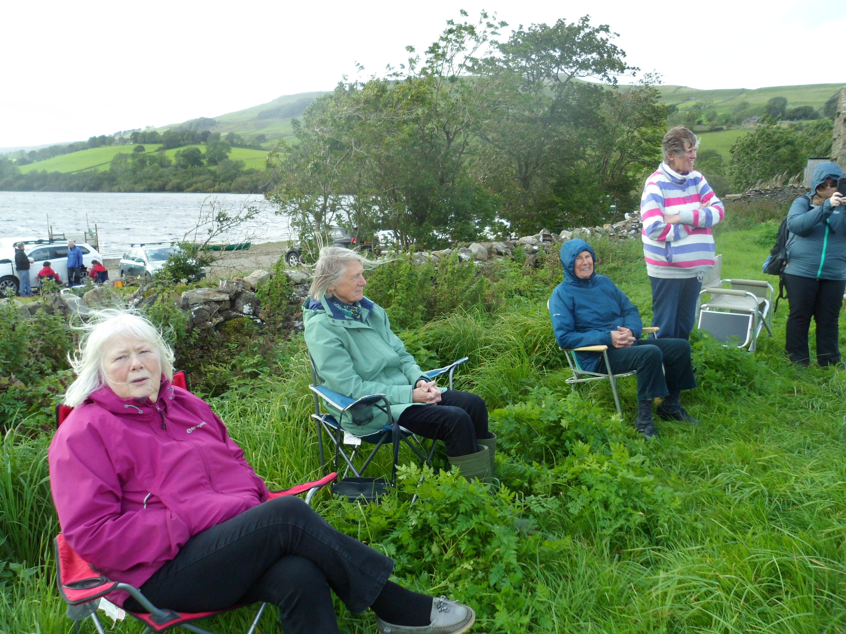
You should have seen us … on a very cold and windy day, thirteen members turned up at Semerwater to meet Jackie Masterman’s Alpaca’s. It was a lovely sunny day, but I am not sure we all realised quite how cold the wind was going to be coming off Semerwater! There we sat in deckchairs with our winter coats, hats, scarves and gloves on!! We must have looked a sight!

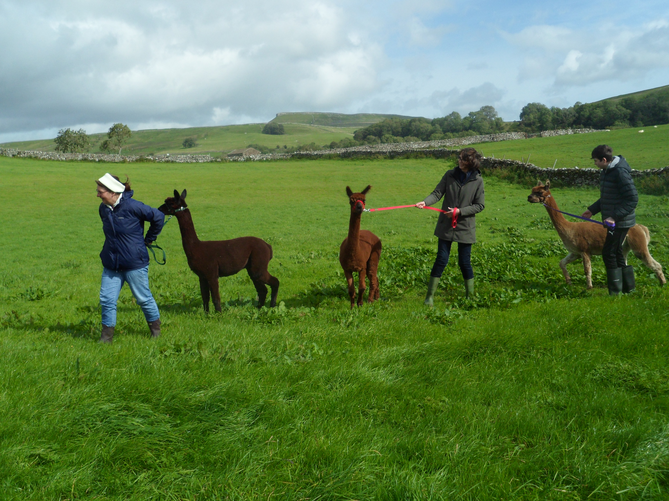
Anyway, eventually we saw Jackie and two friends, walking down the road towards us with three gorgeous Alpaca’s. We were getting excited and then one decided that they would just sit down on the road and have a roll amongst the grit! It was very amusing, although would probably have been less so had there been much traffic heading their way! Apparently, they like doing this in the same way some other animals enjoy a roll in a dust bath.

When they eventually arrived in the field opposite the ‘beach’, Jackie told us that she had brought along her three youngest Alpaca’s - Henry, Harrison and Mr D’Arcy! They were having a wonderful time, munching on the long grass, whilst Jackie told us all about them, battling the wind to get the words to reach us! Alpaca’s are part of the camel family and are the smaller relation to Llamas (they also don’t spit, like the llamas do!). They are intelligent animals and are very good at watching over what is going on. In fact, they are sometimes used to protect sheep from predators. Jackie also told us that they are very clean animals, only using one location as their toilet (in this case, the middle of their barn), whilst each sleeping on their own in the same place around the edge of the building. They are, however, not keen on the dark, so they sometimes need to be encouraged to enter a dark building - I know how they feel.

Each Alpaca needs to be shorn once a year, generally during the summer, and this is quite a specialised job as it needs to be done with the animal on a table, not as with sheep, between the shearers legs. It must be quite an effort to get these animals up onto a table and sitting still for long enough to be shorn! Each shearer has their own trademark and last year, it was a ‘bobble’ which each animal had at the top of their tail - poor things! This year’s was a bit more subtle with the tail being shaped. Jackie told us that when one of her animals was shorn this year, his coat was 5” from his skin to the end, which is quite a significant amount of wool! No doubt he would have been thrilled to lose this had it been a tropical summer, but perhaps during a Dales summer, he would rather have hung onto it!

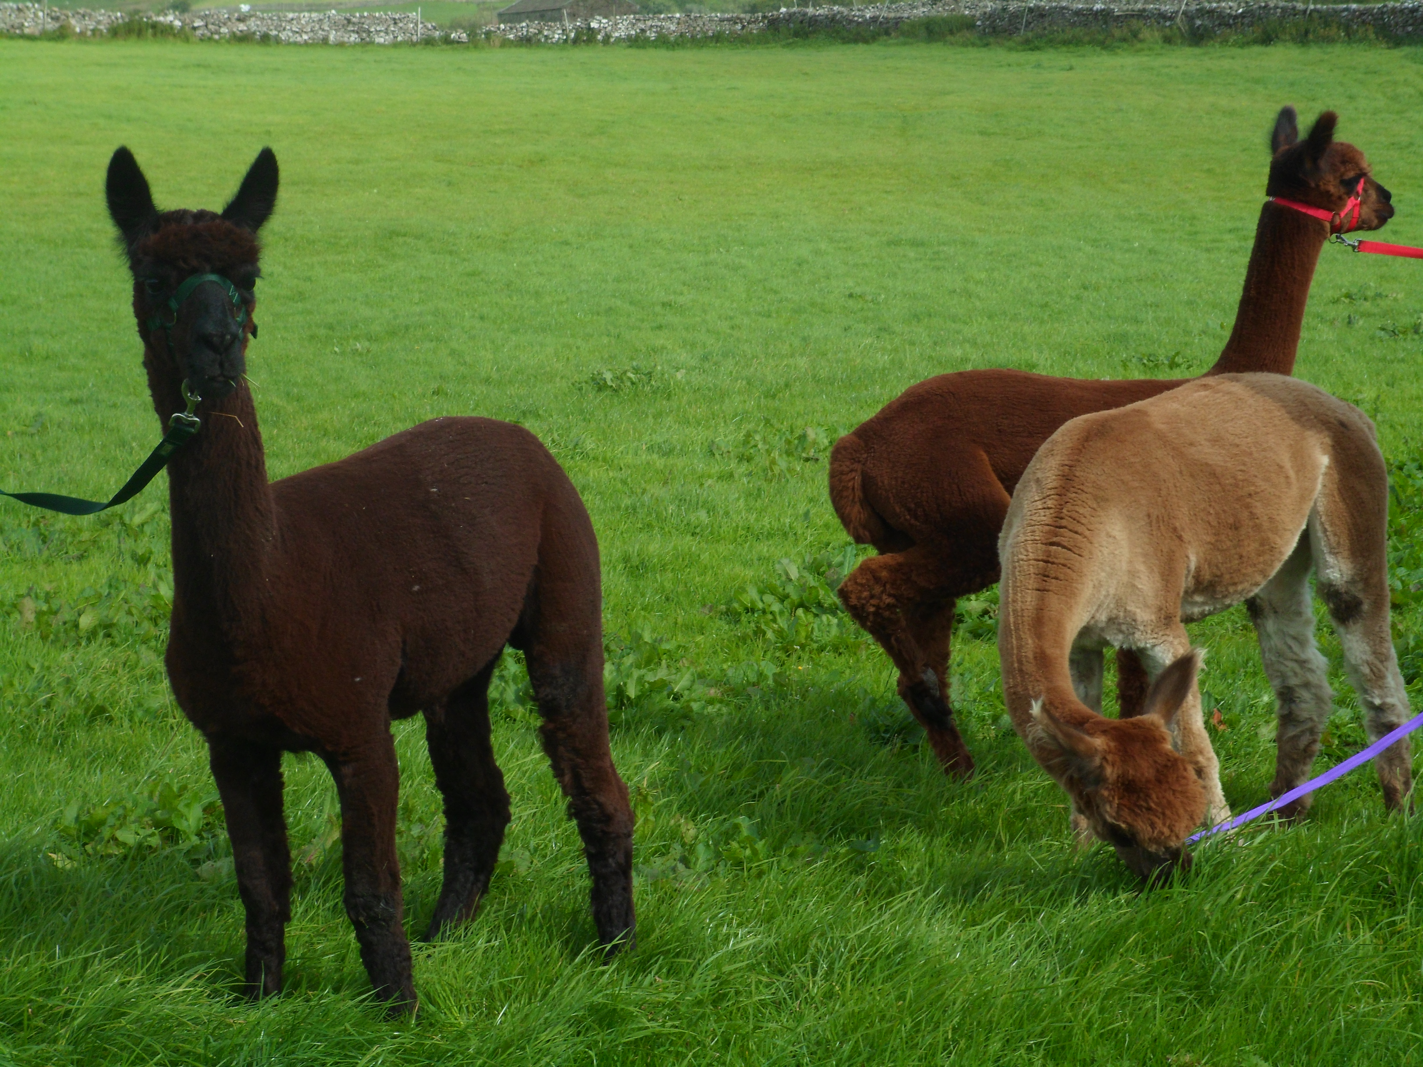
Jackie gave each of us a ‘goody bag’ containing wool from one of the younger animals and one of the older ones. The coat changes as the animals get older and this was quite obvious from the samples she showed us. Of course, Alpaca wool is a very fine, soft wool and is used a lot these days by artisan craftspeople and thus it sells for a better price than sheep wool. Jackie is also using their ‘poo’ to make fertiliser which she told us has travelled as far as London and is much sought after! You know where to go if your garden is in need of a bit of help!!!

Apparently, Alpaca’s do not like being on their own, so if you were thinking of getting one to keep your lawn in check, you actually need three (in case one dies!), so that ruled out a new lawnmower for me!

We were staggered at just how knowledgeable Jackie was about her latest acquisitions and were impressed to hear later that this was her first talk to a group of people - we would never have known! When we had all had the chance to stroke the animals (tricky, as they are quite flighty and wary) we got to feed them with a mineral supplement that they have each day. Goodness, were they keen on that?! The strength in their heads as they dived into the little tubs to gobble up this stuff was very impressive. There was certainly no holding back and very little in the way of table manners!

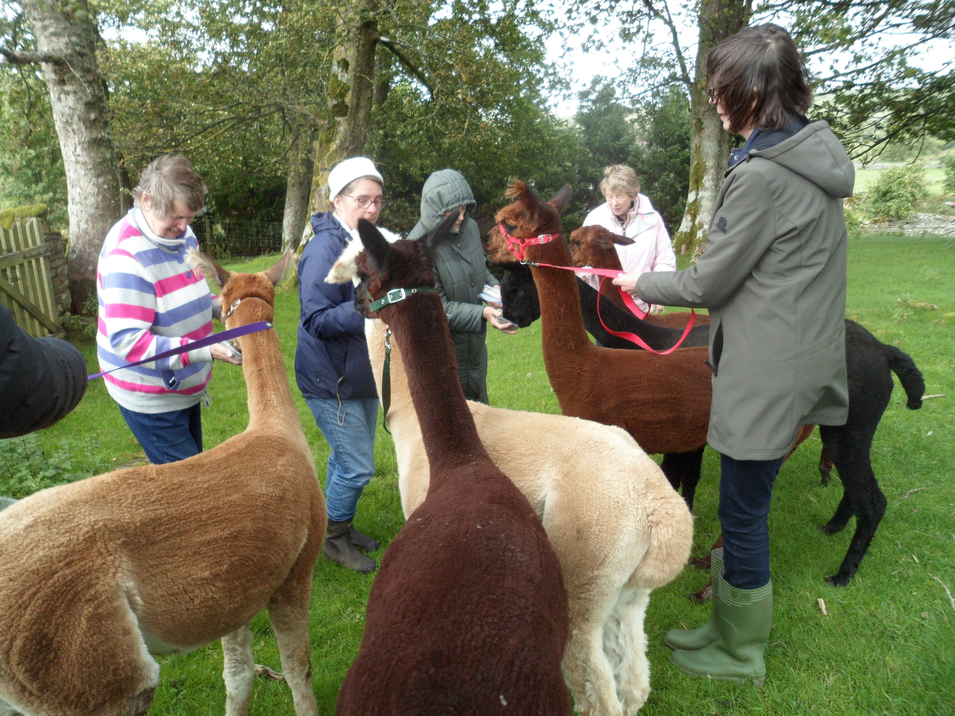
When we had listened to Jackie’s talk, some of us walked back with her and the three younger animals to the field where they all live and we saw the three older Alpaca’s and were able to feed them too. One of them was 20 years old and they can apparently live a few years beyond that, so they are quite a commitment.

Aside from the cold, this was a really lovely visit and we all came away knowing a whole lot more about Alpaca’s. It will be interesting to see how many of us are able to create something from our wool samples!

OCTOBER MEETING
Our planned speaker for October, Professor Charlotte Roberts, has agreed to give us her talk via ‘Zoom’. This will take place on Thursday 15th October starting at 7.00 pm. If you would like to hear this talk and have access to a computer with internet, and an email account, please let Susan know in order that we can send you the link to join. You do not need to download anything to your computer/tablet - all you need to do is click on the link and then join the meeting. You do, however, need a speaker if you want to hear, and if you want us to see you whilst you listen, you will need a webcam too!

BOOK CLUB
Our avid readers are still hard at it, and meeting virtually to discuss their reads. Diana has chosen the next book which is ‘The Wench is Dead’ by Colin Dexter and Susan has chosen the subsequent book which will be ‘The Salt Path’ by Raynor Winn. If you wish to join the club, just get in touch with Susan for details.

GARDEN CLUB
With the weather changing and winter fast approaching, this Club will wind-down with a visit to Thorp Perrow on Saturday 10th October. This CANNOT BE A GROUP VISIT as it would breach Covid-19 restrictions (the ‘Rule of Six’) and therefore if anyone wishes to go along, you must do so independently under your own steam. That said, Susan will be in the car park at 11.00 am on this day to meet any members who wish to visit and, provided groups don’t exceed six in number, it will be possible to walk around with friends. Entry fees apply (£10.95 or £9.95 for concessions) and mobility scooters can be booked in advance by contacting Thorp Perrow direct. Hopefully, the weather will be kind to us for this visit and the arboretum will perhaps be in the throws of a fantastic display of autumn colours.

We are already looking to plan visits to numerous gardens during 2021, but of course, this all depends upon Covid restrictions prevailing at the time. We also hope that some of our members will consider opening their gardens to allow members to visit, but clearly this is likely to be later in the year when the plants are in bloom.

CAKE STALL AT SYCAMORE HALL
The committee have decided that it is almost impossible to hold any fundraising or social events with the current restrictions in place. However, we have established that we are able to hold a Cake Stall at Sycamore Hall, operating within the current guidelines (as things currently stand). Consequently, we intend to do this on FRIDAY 30th OCTOBER between 2.00 pm and 3.00 pm. Karen will man the stall as she already works in Sycamore Hall and therefore there should not be a problem with her being there. We would like to appeal to our members to bake for this stall and donate your baking, as well as any homemade jams etc you may have. Sycamore residents love cake and biscuits, but you should bear in mind that they are unlikely to want too many big cakes (unless they can be cut and frozen). There are also a number of diabetic residents so if any of our members are particularly adept at baking using little or no sugar, those items would also be much appreciated. We would ask that you take great care with hygiene when you are baking and wrap your cakes/biscuits in plastic bags, labelling the bag with details of the contents (and also any allergens, eg nuts). We want to do all we can to ensure that this activity meets all the current guidelines etc and shows the WI in a good light. Your donations should be taken to Karen (Coatie, Bainbridge) by Thursday 29th October as she will take them to Sycamore Hall herself on the day of the sale. Of course, the public are now allowed into Sycamore Hall (as rules currently stand) and therefore it is possible that anyone could visit the stall, however, we anticipate that in the main, it will be residents. If this proves successful, we aim to hold more such sales, not only to boost our funds but to allow the reputation of the WI as excellent bakers to be appreciated!

OUR ANNUAL GENERAL MEETING
Our AGM should be held on Thursday 19th November, but clearly it is not possible for us all to meet in the Village Hall due to the current restrictions. Consequently, we are planning to hold the meeting via ‘Zoom’. We will start with the business of the meeting and then intend to hold a fun quiz. Once again, if you have access to a computer/tablet and would like to join us, please let Susan know so that we can ensure you are sent the link to join. Prior to the meeting, we will be sending the annual reports to all our members along with nomination forms for President and Committee members. I can advise you that all of our current Committee members are happy to remain in post for another year, but if you would like to join, or would like to nominate another member to join, please say so on the form you will be receiving. Likewise, if you wish to nominate any member to take on the role of President, please complete that on the form. All forms should be returned to Susan (or any committee member to pass on) and she will then approach anyone nominated to check that they would be happy to take on the role. If there is more than one nomination for President, then we will need to hold an election and you will be sent a voting form to complete and return. This all sounds very complicated, but hopefully it will work quite smoothly. We hope that you will make the effort to join us on the evening from the comfort of your own home.

CHRISTMAS PARTY
Clearly this year, Christmas is going to look very different to previous years. We had hoped that we would somehow be able to go ahead with a Christmas Party but, following enquiries of various local venues, and now having had additional restrictions placed upon us, it is clear that we are not going to be able to have a party this year. Naturally, we are all very disappointed, particularly as we had hoped this would give us the opportunity to meet up with members who we have not seen for most of the year. However, we must all put our health and safety first and clearly cannot break the guidelines in place. The Committee are currently looking at ways in which we can reach all our members at this time of year, and we hope to come to some practical decisions over the next few weeks. Like everyone else, our priority must be to obey the regulations and hopefully ensure that at least our family Christmas can go ahead as we all hope.

2021 DIARIES
This is a last reminder that the WI 2021 diaries are now available and we need to place our order. They cost £5.10 and if you want one, please make sure that Susan knows before the end of October. The order will be placed and payment made in early November and we will then try and arrange some way to deliver diaries to those who have ordered them, and to take payment.

FEDERATION NEWSLETTERS
We are still awaiting a response from several members as to whether they wish to continue to receive a copy of the monthly Federation Newsletters. We have paid up until the end of March 2021 for our current members but will need to place a new order from April 2021 for our members at that time (don’t forget that next year, membership of the WI renews from April, not January). Please contact Susan to let her know if you wish to have a copy of the Newsletter and if so, whether you prefer a paper copy or an email one. We have to pay an amount for each member’s Newsletters and we are aware that some of you don’t actually read them, so we don’t want to waste any more money or paper than we have to! Please ensure you contact Susan whilst you remember.

2021 MEETINGS
Obviously, it is proving quite difficult to plan anything with Covid still amongst us. However, we now have a full programme of meetings for 2021, along with plans for our clubs, visits and other activities. We will let you know as soon as we are able what we hope 2021 will look like for our WI, but it is clear that we are all going to have to be flexible and react to changing guidance, particularly until such time as an effective vaccine is found. Having said all that, we will be booking Bainbridge Village Hall for our regular monthly meetings on the third Thursday of the month, starting at 7.30 pm, with our first meeting planned for Thursday 21st January. Fingers crossed that we will be able to get together then!

ONE VERY ACTIVE COMMITTEE MEMBER!
As I write this Newsletter, our very own Janine is doing a sponsored walk, raising funds for the British Heart Foundation. She will be walking twenty miles around the Lake District between 3rd and 7th October and we hope that the weather has been kind for her, although even as she was telling us about it, the forecast wasn’t looking particularly favourable. Some of you may already have sponsored Janine, but if you haven’t and would like to, please get in touch with her upon her return. Rest assured this sort of activity is not a requirement for WI committee members, but we very much admire Janine for her efforts and hope that they were worthwhile and her feet recover soon!

YORE CLUB
You may have read in the Upper Wensleydale Newsletter that Eleanor Scarr and Ann Deans have decided to ‘retire’ from the Yore Club after many years organising an annual programme of events and numerous trips for the senior members of our community. Well, the good news is that the Club is not going to fold because our very own Karen has come forward to take over the organisation. Of course, nothing can be planned yet because of Covid restrictions but hopefully this will allow Karen time to get plans in place for the Club to resume as soon as it is safe to do so. As many of us have enjoyed Yore Club meetings and trips over many years, we would like to thank Eleanor and Ann for their hard work and commitment and wish them well in their retirement.

So, as we anticipate a long winter ahead of us and, in all likelihood, one like no other we have experienced with various restrictions still in place, remember that the WI is still here for you. We do not want any of our members to feel isolated so if you feel in need of company, please give Susan a call to arrange either a visit or a telephone call from one of our members. We all know it is good to chat and we are all here for each other during these challenging times.

With every best wish from your President and members of the Committee.

TAKE CARE AND STAY SAFE!

********************************************************

THIS MONTH’S QUIZ
A little bit of General Knowledge this month.
Good luck!

1. Who played Bob in the classic comedy series ‘The Likely Lads’?
2. According to the Bible, who baptised Jesus?
3. Who was the eldest of the Bronte sisters?
4. Which star of ‘Yes Minister’ also played the role of Jerry Leadbetter in ‘The Good Life’?
5. Which large aquatic rodent builds lodges and dams?
6. Who played Nora Batty in ‘Last of the Summer Wine’?
7. In which year did the General Strike take place in Britain?
8. What is the collective name for a large group of goldfinches?
9. What is the Capital of Brazil?
10. Which British Monarch died in 1901?
11. What is the common name for the ‘clavicle’ in the human body?
12. What was the name of the sequel to Lewis Carroll’s ‘Alice in Wonderland’ book?

Answers to Last Month’s Quiz

1. Saturn
2. Radius and Ulna
3. Versatile
4. Badger
5. Chlorophyll
6. Ballistics
7. Cob
8. Salt
9. 15
10. One Calorie

