

Bainbridge WI NEWSLETTER

August 2020

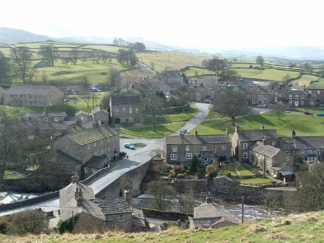

President:

Susan Freer

‘Sheepscar’, Thornton Rust,

Leyburn, DL8 3AN

Telephone: 01969-663980

Email: [susanfreer@btinternet.com](mailto:susanfreer@btinternet.com)

**WELCOME TO SUMMER!**

August already? Where has this year gone? I hate to say it, but we will soon have to start thinking about Christmas!!

Anyway, since lockdown restrictions started to ease, the weather seems to have deteriorated. Could that be so that we are not inundated with visitors who seem to suffer with ‘summer madness’ when the weather is lovely and forget all thoughts of obeying the guidance?! Perhaps it is just that we had our quota of lovely weather during the early part of lockdown and there is no more to go around? Whatever the reason, it is a shame that we no longer have the continuity of lovely weather day after day and that will impact on just how much we are able to enjoy outside, which seems to be the safest place to be these days. However, that hasn’t stopped the Committee from planning some outdoor events for you all, and we very much hope that those of you who can will do your best to join us.

**PICNIC ON THE GREEN**

Having had to cancel our first date to meet on Bainbridge Village Green due to the rain, the following Saturday dawned dry and bright and we were able to go ahead. Fourteen members turned up with their deckchairs and picnics and sat around in a socially distanced circle – we were quite a curiosity to the passing traffic! It was really lovely, at last, to be able to get together with friends and have a chat about what we had all been doing during lockdown and how we had survived. Lockdown hair was of course one of the big topics of discussion and we were all grateful that our hairdressers were finally back in business!

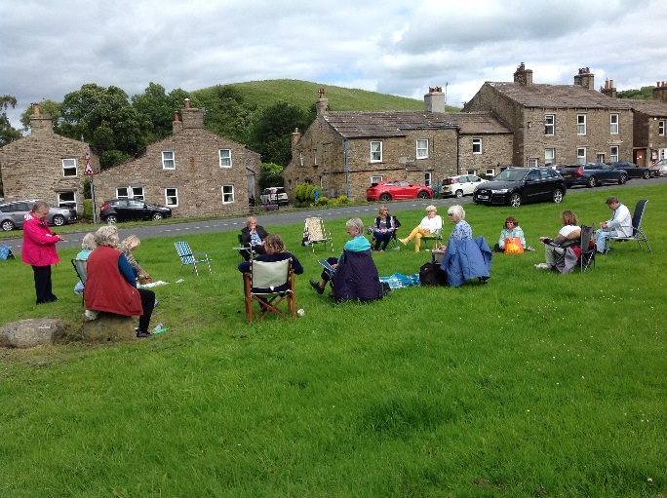

Given that meeting up outside seems to be the safest option to get together with friends at the moment, we hope that, if we are blessed with some more nice weather over the next couple of months, we may be able to arrange similar get-togethers, even if only at short notice by a telephone call. If that proves to be the case, we hope you will come along and join us.

**FROM DOCTOR TO AUTHOR**

On 23rd July, eight members enjoyed a ‘virtual’ talk by Carol Tetlow, who had been booked to be the speaker at our August meeting. This was the first time we had attempted a ‘virtual WI meeting’ and Carol said she was honoured to be our first ‘virtual’ speaker. Carol retired as a GP in 2014 and lives locally with her husband, four dogs, five donkeys and 2 cats! She told us all about her life as a doctor, first in hospitals but then specializing in general practice. There were some very humorous tales along the way as well as heart-rending stories of people she had met and helped. Following retirement, Carol started writing and is now an accomplished author, after some years of effort to find a publisher willing to publish her tales of life as a doctor. She now has five books published (all available via Amazon) and, given how interesting her talk was, these are bound to be a really good read. All those who took part in this meeting enjoyed Carol’s talk and no doubt very swiftly afterwards took a look on Amazon for her books! We are grateful to Carol for bravely being our first ‘virtual speaker’ and providing us with some light entertainment at home.

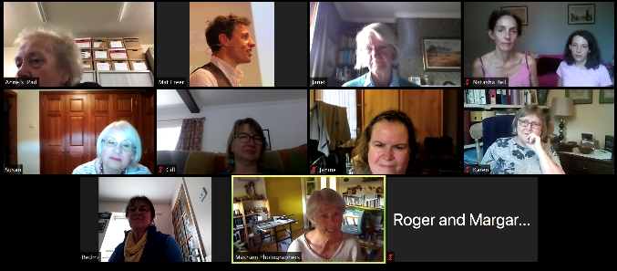

**VIRTUAL MEETINGS**

It is looking increasingly likely that we will be unable to resume our regular monthly meetings this year, due to the numerous guidelines in place to prevent a further outbreak of the pandemic. Consequently, the Committee are looking into ways to remain in touch with members and to offer them some form of WI activity. Clearly, outdoor events are one way to do this, but they are very weather dependent, and now we are heading alarmingly quickly towards autumn, it seems logical that the number of lovely dry days are likely to diminish. Consequently, like many other WI’s we are now considering increasing our offering of ‘virtual meetings’. Obviously, these are only available to members if they have access to a computer/iPad/tablet and have an email account. However, we have now demonstrated that it is possible to enjoy a speaker/demonstration from the comfort of your own home, via this method.

We would therefore like to hear from you if you do have a computer or tablet and would like some help in finding out how to join our ‘virtual meetings’. We currently use ‘Zoom’ to host these meetings but there is no need for you to download that software to your computer. Instead you would need to register your interest with us in joining a meeting and we will then send you an email with an invitation to join. At the time the meeting takes place, all you will need to do is click onto this link and it will take you direct to the meeting, where you will be able to see and hear not only our speaker, but also all those members who are joining in.

We accept it won’t be possible for everyone to join us in this way but we do hope that more of you will consider it as an option during these challenging times. Please contact Susan if you are interested in getting more information.

**FORTHCOMING EVENTS**

**Visit to the Kennel Field in Thornton Rust** – This event is planned to take place at **2.30 pm on** **Saturday 5th September,** weather permitting. We are currently arranging for a local expert to come and give us a brief talk about the history of the field as well as the flowers and wildlife we may see there. This will be followed by a picnic (bring your own chair and food), and a walk over Addlebrough - for those who are feeling energetic. Please park in the car park near the Kennel Field (up the lane opposite the Institute).

The **Book Club** is still reading avidly and gets together via Whatsapp. If you are interested in joining, please contact Susan.

**Lunch Club** is still unable to meet due to social distancing regulations, but as soon as it is possible for a group of people from different households to get together indoors (close enough to chat) we will look forward to it resuming.

The **Garden Club** launched on 1st August (Yorkshire Day!) with visits to Anne’s, Janet’s and Susan’s gardens in Thornton Rust. Thankfully, the weather was kind and we were able to enjoy a leisurely afternoon checking out these gardens and enjoying refreshments along the way. Thanks to our hosts for their hospitality. There are some photos of the gardens in this newsletter.

The **Craft Club** has some events planned for later in the year and is waiting to see whether these will be able to go ahead. We will keep you informed.

**DENMAN**

Sadly, the WI has announced that it will not be re-opening Denman College following the pandemic. For many years it has been challenging to find sufficient funds to meet the many overheads of such a large place and the difficult decision has now been made to close it and sell the property. No doubt many of you have visited over the years and enjoyed the very special atmosphere and opportunities provided there, but increasing costs mean it is no longer viable to continue. We believe that anyone who has a booking and has paid money will be refunded.

**UPPER WENSLEYDALE NEWSLETTER**

The Upper Wensleydale Newsletter has now returned to print with the August issue and should be available from your local outlets.

**BAINBRIDGE WI WEBSITE**

If you have computer access, don’t forget to regularly check out our new website ([www.bainbridgewi.com](http://www.bainbridgewi.com)) where you will find information and photographs of our activities.

**AND FINALLY ….**

We all hope that things will start to improve and the restrictions on our lives will ease, but returning to what we considered to be ‘normal’ still seems a long way off. Rumour has it that we will be living with this virus for some time, quite possibly well into next year, until a vaccine can be found, so we are certainly going to need to learn to adapt to this ‘new normal’ everyone is talking about. It sounds like we still have challenges ahead, and that is without any mention of a possible second-wave of the virus! All we can do is to make sure that we take every effort ourselves to respect the guidance, maintain social distancing and good hand hygiene, and limit the number of people we are in contact with. This last suggestion goes against everything that is so special about living in this wonderful area, so it is not going to be easy, but we must do it for our own sake and that of those we love and care about.

Meanwhile, your committee members are still thinking of you all and hoping that you are coping with the restrictions as best you can. If you need any help, or someone to talk to, please contact Susan in the first instance. **YOU ARE NOT ALONE WITH THE WI**!

With every best wish from your President and members of the Committee.

**TAKE CARE AND STAY SAFE!**

**THIS MONTH’S QUIZ IS GENERAL KNOWLEDGE**

**GOOD LUCK!**

1. How many great grandchildren does HM Queen Elizabeth II have? Can you name them?
2. What is the best-selling single of all time?
3. During which battle of the Crimean War did the Charge of the Light Brigade take place?
4. Who wrote the opera Prince Igor?
5. Which of the Gospels records the Sermon on the Mount, including the Beatitudes and the Lord’s Prayer?
6. On what island did Napoleon die in exile?
7. Who played Baldrick in the Blackadder comedy series?
8. What was the theatrical profession of Joseph Grimaldi?
9. What is the date of St Swithin’s Day?
10. Which royal figure is credited with popularizing the Christmas tree in Britain?
11. Who was Poet Laureate from 1972 to 1984?
12. What name is given to a boat whose hull is raised out of the water when moving at speed?
13. Of which country is Zagreb the capital?
14. Which Roman Emperor was assassinated in the Senate House on the Ides of March?
15. Who wrote the novel Moby-Dick?
16. The Yen is the national currency of what country?
17. What type of animal is a macaque?
18. Who was the third wife of King Henry VIII?
19. What is the name given to something used to tie a blood vessel to stop it bleeding?
20. Which children’s novel by Mary Norton describes a family of tiny people who live under the floor?

Answers to Last Month’s Quiz:-

1. A Midsummer Night’s Dream
2. MacBeth
3. The Merchant of Venice
4. Richard III
5. The Merry Wives of Windsor
6. The Tempest
7. Hamlet
8. Measure for Measure
9. The Comedy of Errors
10. All’s Well That Ends Well
11. Edward III
12. Coriolanus

How well did you do?

